**EXPERIMENT 9**

**Aim**: To implement Service worker events like fetch, sync and push for E-commerce PWA

**Theory**:

# Service Worker

Service Worker is a script that works on browser background without user interaction independently. Also, It resembles a proxy that works on the user side. With this script, you can track network traffic of the page, manage push notifications and develop “offline first” web applications with Cache API.

Things to note about Service Worker:

* A service worker is a programmable network proxy that lets you control how network requests from your page are handled.
* Service workers only run over HTTPS. Because service workers can intercept network requests and modify responses, "man-in-the-middle" attacks could be very bad.
* The service worker becomes idle when not in use and restarts when it's next needed. You cannot rely on a global state persisting between events. If there is information that you need to persist and reuse across restarts, you can use IndexedDB databases.
* Service workers make extensive use of promises, so if you're new to promises, then you should stop reading this and check out Promises, an introduction.

# Fetch Event

You can track and manage page network traffic with this event. You can check existing cache, manage “cache first” and “network first” requests and return a response that you want.

Of course, you can use many different methods but you can find in the following example a “cache first” and “network first” approach. In this example, if the request’s and current location’s origin are the same (Static content is requested.), this is called “cacheFirst” but if you request a targeted external URL, this is called “networkFirst”.

* **CacheFirst** - In this function, if the received request has cached before, the cached response is returned to the page. But if not, a new response requested from the network.
* **NetworkFirst** - In this function, firstly we can try getting an updated response from the network, if this process completed successfully, the new response will be cached and returned. But if this process fails, we check whether the request has been cached before or not. If a cache exists, it is returned to the page, but if not, this is up to you. You can return dummy content or information messages to the page.

# Sync Event

Background Sync is a Web API that is used to delay a process until the Internet connection is stable. We can adapt this definition to the real world; there is an e-mail client application that works on the browser and we want to send an email with this tool. Internet connection is broken while we are writing e-mail content and we didn’t realize it. When completing the writing, we click the send button.

Here is a job for the Background Sync.

The following view shows the classical process of sending email to us. If the Internet Connection is broken, we can’t send any content to Mail Server.

# Push Event

This is the event that handles push notifications that are received from the server.You can apply any method with received data.

We can check in the following example.

“Notification.requestPermission();” is the necessary line to show notification to the user. If you don’t want to show any notification, you don’t need this line. In the following code block is in sw.js file. You can handle push notifications with this event. In this example, I kept it simple. We send an object that has “method” and “message” properties. If the method value is “pushMessage”, we open the information notification with the “message” property.

CODE-

Service-worker.js // Import Workbox

importScripts('https://storage.googleapis.com/workbox-cdn/releases/6.4.1/work box-sw.js');

if (workbox) { console.log(' Workbox Loaded Successfully');

// Precache assets workbox.precaching.precacheAndRoute(self.__WB_MANIFEST || []);

// Cache Images (Cache-First Strategy) workbox.routing.registerRoute(

({ request }) => request.destination === 'image', new workbox.strategies.CacheFirst({ cacheName: 'images-cache', plugins: [ new workbox.expiration.ExpirationPlugin({ maxEntries: 60, maxAgeSeconds: 30 * 24 * 60 * 60, // 30 Days

}),

],

})

);

// Cache CSS & JS (Stale-While-Revalidate Strategy) workbox.routing.registerRoute(

({ request }) => request.destination === 'script' || request.destination ===

'style',

new workbox.strategies.StaleWhileRevalidate({ cacheName: 'static-resources',

})

);

// Cache API Responses (Network-First Strategy) workbox.routing.registerRoute(

({ url }) => url.origin.includes('api.themoviedb.org'), new workbox.strategies.NetworkFirst({ cacheName: 'api-cache', plugins: [ new workbox.expiration.ExpirationPlugin({ maxEntries: 50, maxAgeSeconds: 5 * 60, // 5 minutes

}),

],

})

);

}

// Fetch Event Logging (Works outside Workbox) self.addEventListener('fetch', (event) => { console.log(` Fetch event detected: ${event.request.url}`);

if (event.request.url.includes('api.themoviedb.org')) { console.log(`Intercepting API Request: ${event.request.url}`);

event.respondWith( caches.match(event.request).then((cachedResponse) => { return cachedResponse || fetch(event.request).then((response) => { console.log(` API Response Fetched: ${event.request.url}`); return response; }).catch((err) => { console.error(` API Fetch Failed: ${event.request.url}`, err); return new Response('API fetch failed', { status: 500 });

});

})

);

}

});

// Background Sync Event (Syncing Watchlist) self.addEventListener('sync', (event) => { if (event.tag === 'sync-watchlist') { console.log(' Sync event triggered: sync-watchlist'); event.waitUntil( syncWatchlist().then(() => { console.log(' Sync successful');

}).catch((err) => { console.error(' Sync failed:', err);

})

);

}

});

// Example Function to Sync Watchlist async function syncWatchlist() { console.log(' Syncing watchlist data...'); return fetch('/sync-watchlist', { method: 'POST' })

.then(() => console.log(' Sync request sent successfully!'))

.catch(() => console.log(' Sync request failed, retrying later.'));

}

// Push Notification Event self.addEventListener('push', (event) => { console.log('Push notification received');

const notificationData = event.data ? event.data.text() ; console.log(`📨 Push payload: ${notificationData}`);

const options = { body: notificationData, icon: '/logo192.png', badge: '/logo192.png',

};

event.waitUntil( self.registration.showNotification(' Movie House', options)

.then(() => console.log(' Push notification sent successfully'))

.catch((err) => console.error(' Push notification failed:', err))

);

});

// Activate event - Cleanup old caches self.addEventListener('activate', (event) => { console.log(' Service Worker activated'); event.waitUntil( caches.keys().then((cacheNames) => Promise.all( cacheNames.map((cache) => { if (!['images-cache', 'static-resources', 'api-cache'].includes(cache)) { console.log('🗑 Deleting old cache:', cache); return caches.delete(cache);

}

})

)

)

);

self.clients.claim();

});

OUTPUT

Service worker activated

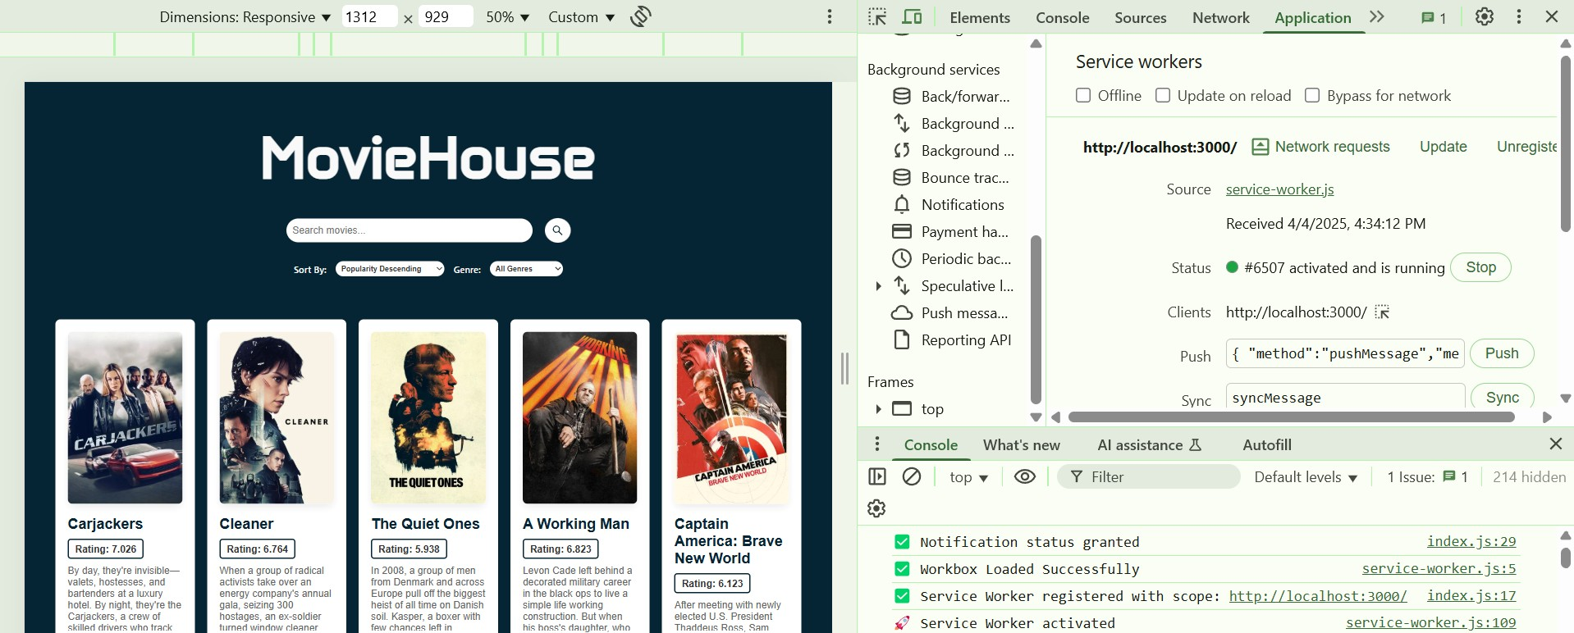

Fetch Event

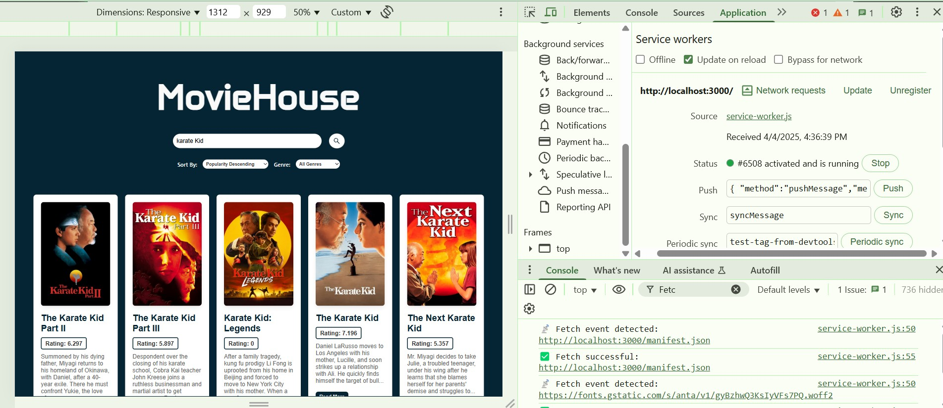

Sync Event

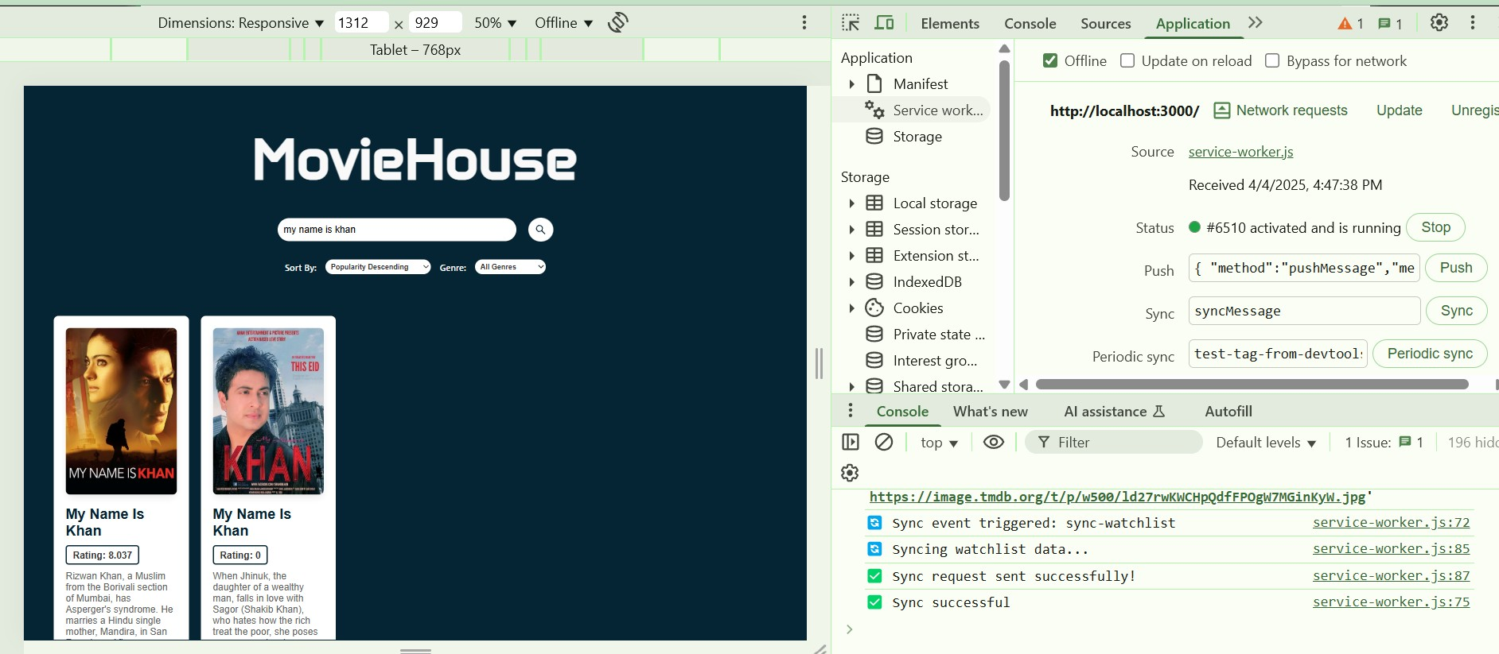

Push Event

